(Approx. 1046 words)

How to Clean Your Dirty Laptop
Author: David Kretchmar, Computer Technician
Sun City Summerlin Computer Club, NV
September 2019 issue, Gigabyte Gazette
www.scscc.club
dkretch at gmail.com

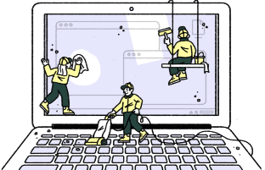
After being used regularly for months or years, our laptops accumulate dust, grime, skin oils, sneezes, and who knows what else. Your laptop is most likely due for a cleaning, and I’m going to pass along some suggestions on how to do it effectively without harming this delicate piece of equipment.

You know your laptop is filthy. You can see the dirt and grime on your keyboard. You might also be able to see grime accumulated on your trackpad. So, it’s time for a cleaning.

A shining newly cleaned laptop is a joy to use; the keys are clean; the screen is free of smudges and splatters. These cleaning suggestions might also be useful if you buy a used laptop, since the previous owner doesn’t always leave them in pristine condition.

Your Supplies
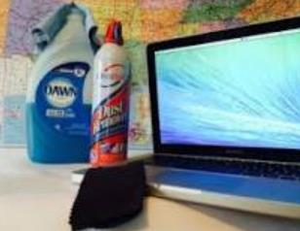
You don’t need much to clean a computer; rubbing alcohol, a mild dish detergent, soft lint-free cloths (microfiber cloths are ideal), Q-tips, and canned air. Ninety percent or higher isopropyl alcohol is what you want, since it won’t damage the internal components. And if you have some particularly embedded dirt, a Mr. Clean Magic Eraser (or other melamine sponge) can also work wonders, though it should be an absolute last resort since it’s abrasive and can leave permanent scratches.

Don’t waste your money on specialty cleaners you see at big box electronics stores like Best Buy. They work just fine but no better than what you have at home.

Start With the Inside
Starting with that dirt on the keyboard and screen might be tempting, but you should start with the internals. Canned air will blow dust and dirt everywhere, so if you started by cleaning the screen, you’ll just end up having to clean it again after you’ve used canned air. Start by blowing out the dust, then move on to the outside.

You shouldn’t have to open your laptop to clean the inside. Turn off the laptop, unplug the power cable and remove the battery, if it pops out (removable batteries are becoming a thing of the past). Give the canned air a quick burst away from the laptop to get rid of any condensation, and then start blowing air into any cracks and crevices: the keyboard, the vents and even the USB and other ports. Blow in short bursts, since longer sprays can cause moisture to accumulate inside your computer. You can also damage the fans by making them spin too fast.

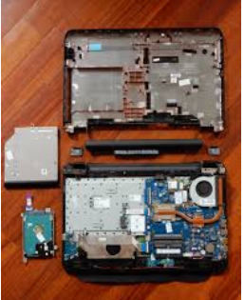
You probably won’t see a big change after doing this. The goal is to prevent dust buildup over time, which can cause your laptop to overheat and possibly spontaneously shut down. If you can see dust bunnies in the vents, you’ve let it go too long without a cleaning. If there is a dust bunny that you see is stuck behind the vent that you can't dislodge by blasting it with compressed air, consult your user manual on how to open the case. Be sure you remember which screws went where for the reassembly; snap a picture or two of your laptops before opening the case for a reference and be super-organized with the screws as you remove them.

Smokers and pet owners should take special care to clean the inside often, since you’re likely to experience much quicker buildup of dust, smoke, hair and other dirt.

Wipe Down the Outside
Remember, when cleaning a laptop (or desktop) computer, you want to apply the cleaning product to the tool you’re using to clean, never ever directly onto the computer. So, grab your microfiber cloth, pour a little alcohol onto it, wring it out so it isn’t dripping wet, and wipe down the surface. Cotton swabs with alcohol are useful for the keyboard keys and the small spaces between them. (If there are marks that won’t come off, you can try rubbing them with a Mr. Clean Magic Eraser or other cleaner very lightly, but again, they’re mildly abrasive and this can alter the finish of the surface.)
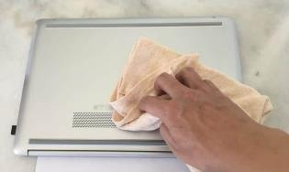
It may take a few passes to get all that grime off, but once you do, you should notice a dramatic difference. If your laptop is particularly old, you may not be able to get rid of the shine on the keys; some of us may have worn down the top layer of plastic and even the letters on the keys. There’s not much you can do about that.

You should be able to wipe fingerprints off your screen with a dry microfiber cloth. If you need some more cleaning power, a slightly damp cloth that has been completely wrung out first, can help. Some manufacturers, including Dell and Lenovo, even say you can use a 50:50 mixture of isopropyl alcohol and water, if need be, to remove really tough dirt. Just avoid household cleaners with harsher chemicals like ammonia or Windex on the screen.

Get Rid of Bad Smells
Let’s say you have a particularly terrible case of gross laptop, and even after the above steps, your laptop still carries the essence of whatever it has been exposed to. I’ve seen many laptops that smelled like smoke and getting rid of that is a challenge or maybe impossible. Cleaning the surface can help, but a lot of those smells may also be inside the computer. For that, you can turn to a natural deodorizer: charcoal. Don’t to go digging through your grill for briquettes – cooking charcoal is different from activated charcoal. Activated charcoal is made with much more (micro) surface area to be more absorbent.

Another common item will do - kitty litter. Because most kitty litter formulas have activated charcoal in them to neutralize litter box smells, it’s a great odor eliminator.
Seal the laptop up in a bag or closable bin with a cup or so of the activated charcoal or litter and leave it for at least 24 to 48 hours. If you don’t have a cat, people also had good luck with diaper pail deodorizers, which are neat little packets of charcoal you can throw away when you’re done. The longer you leave the computer in the bin, the better.

